


A Social Ministry of the ELCA

Master or Doctor-prepared therapists who serve with dedication and skill to grow relationships and heal heart, mind, spirit, and body.
 | We are a group of highly skilled therapists who are dedicated to bringing hope and healing to individuals, couples and families in the Church and in the broader community. We seek to be an extension of the healing and reconciling mission of Christ through counseling, education, training and consultation.  We offer a variety of approaches to individual, couple and family counseling that is evidence-based and spiritually supportive. Most therapists are professionally trained in both psychology and theology and all our therapists are skilled in integration of spirituality and counseling.  Through therapy and educational services, we serve over 11,000 individuals in churches and communities across the greater Puget Sound every year. We provide individual therapy for areas of life that cannot always be addressed by congregational programming such as relationship conflict, depression, anxiety, behavioral problems, sexuality, trauma recovery and grief support. We provide excellent educational programs to support adult and family ministry, including: marriage, parenting, retirement, grief, and divorce.  Many of our clients pay a subsidized fee, adjusted according to family income. This is made possible by the generous donations of the churches we serve. We value professional practices that enable clients to access our ministry easily, through our network of referral sources, and through our varied schedules, multiple locations, and adjusted fee schedule. Most of our therapists accept insurance.  To refer or inquire, please call or check us out on the web: www.lutherancounseling.net  Bellingham: 360-715-2166  Bothell: 425-455-2960  Enumclaw / Federal Way: 253-839-1697  Everett / Marysville: 425-258-2955  Kent / Renton / SeaTac: 425-271-9711  Seattle / Shoreline: 206-364-1046  See reverse for list of therapists and office locations

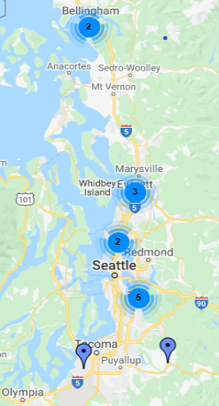 | Enumclaw/Federal Way  253-839-1697  Hope Lutheran: Enumclaw  Pearle Hintz, MS, LMHC  Calvary Lutheran: Federal Way  Janet Cederberg, MA, Deacon, LMHC  Pearle Hintz, MS, LMHC  Everett / Marysville  425-258-2955  Central Lutheran : Everett  Marcia Erickson Bates, MS, LMFT  Bethlehem Lutheran : Marysville  Marcia Erickson Bates, MS, LMFT  Sara Jones, MS, LMFT  Kent / Renton /SeaTac  425-271-9711  Zion Lutheran: Kent  Janet Cederberg, MA, Deacon, LMHC  Pearle Hintz, MS, LMHC  Sarah Goodale, MSW, MTh, LICSW  St. Matthew’s Lutheran: Renton  Janet Cederberg, MA, Deacon, LMHC  Prince of Peace Lutheran: SeaTac  Karen Klemetson, PhD, LMFT  Seattle / Shoreline  206-364-1046  Phinney Ridge Lutheran: North Seattle  Erica Shutes-David, LMFT
Bellingham
360-715-2166
Christ the Servant Lutheran: Bellingham
vacant
Our Saviour's Lutheran: Bellingham
Margaret Pierce, MA, LMHC

Bothell
425-455-2960
Bothell First Lutheran: Bothell
John Koch, Psy.D., LMHC

